ORDER FORM 2022

Name | Contact No:
Address: | E-mail:

Name |  | Image | Price | Quantity |  | Cost
Standard Beanie Bag |  |  | R90.00
Standard Beanig Bag With Cover |  |  | R120.00
Double Beanie Bag |  |  | R140.00
Double Beanie Bag With Cover |  |  | R180.00
Long Back Pack |  |  | R200.00
Long Back Pack With Cover |  |  | R250.00
Improved Short Back Pack (2 ROWS) |  |  | R150.00
Short Back Pack With Cover |  |  | R200.00
Thumb and Wrist Beanie Bag |  | 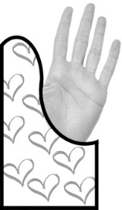 | R120.00
Hand and Wrist Beanie Bag | 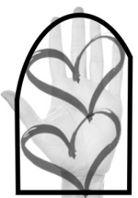 |  | R145.00 | M | L
Thank you for your support!  ELIZE WILKEN  (CELL 082 723 3208) |  |  |  | Amount Received: |  | R
Banking details
Name of account holder: H.E. WILKEN Bank name: NEDBANK
Branch code: 192 841 Account number: 292 804 2679 (Savings Account)

